GEDU 142 – Advanced Writing
POSTECH Division of Humanities and Social Sciences
Fall 2018
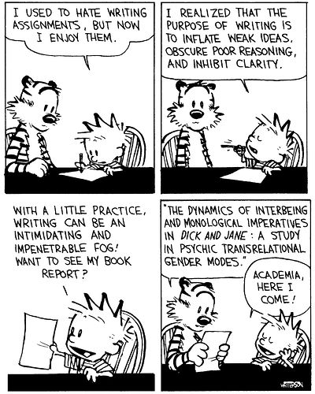

Professor: Steven Amador
Office: Muenjae Memorial Hall, Room 407
Telephone: 279-2722
Email: samador@postech.ac.kr
Office Hours: By appointment

Course Description: Advanced English Composition is a course designed to transition students writing skills from those obtained in Basic English and Grammar/Intermediate Writing to fully academic contexts. In this course, examining language appropriate for academic writing and peer evaluation of work will be pivotal for the development of students’ writing perceptions and growth. Students will produce multiple essays, showing improvement in clarity and depth of language as well as its pragmatic application. Critical evaluation of self and peer work, as well as supporting ideas through research (including citation) are defining themes in this course.

Course Objectives:
• Develop students’ ability to incorporate academic grammar and vocabulary into academic writing in contextually appropriate ways.
• Develop student’s ability to support original and borrowed ideas through citation.
- Develop skills to focus on accuracy and brevity in academic (scientific) writing.
Textbook: Successful Scientific Writing

S/U System: To receive a grade of satisfactory (S) you must obtain an average of 90% or higher and have completed all speaking/writing assignments.

Evaluation Criteria:

- Attendance/Participation – 10%
- In-class work (editing/presentations) – 20%
- Writing assignments – 50%
- Mid Term Examination– 10%
- Final Examination – 10%

Attendance Policy: 100% attendance is expected. If you are absent on a testing/presentation day, you will automatically receive zero points on it. Only in exceptional cases will make-up presentations be permitted. Each unexcused absence will result in a 3% reduction of the final grade. A student who misses 4 or more classes will receive a “U.” Tardiness (being late) is unacceptable. If you are under 10 minutes late for class, 1% will be deducted from your final grade. If you are 10 minutes late or more, you will be marked absent and lose 3% from your final grade.

Communication is very important in this class. If you are having any problems, contact me immediately.

